Stay up to date with AI
Like many technologies, artificial intelligence (AI) is continually evolving, with new tools and breakthroughs announced almost daily. Staying informed about these changes is key to enhancing your work and optimizing your skillset. This guide provides a practical toolkit of strategies and resources to help you keep your AI knowledge up-to-date.
alt=""

Create an AI Information toolkit
Forming a habit of staying informed doesn't have to be time-consuming. The goal is to create a personal, curated collection of sources that you can turn to regularly. Your toolkit can be as simple as a dedicated bookmark folder in your browser, a watchlist, or even a collection of links from trusted sources in a note-taking app. Use any combination of the following strategies to start building your own toolkit:
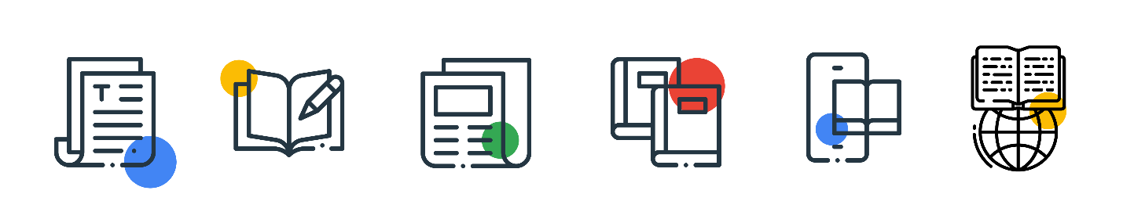
- Curate a reading list: Find a few trusted newsletters or blogs that summarize the week's biggest AI news. A good strategy is to pair an aggregator newsletter like The Neuron with primary sources like the official Google DeepMind Blog for research breakthroughs and The Keyword for the latest Gemini product news.
- Follow the conversation: A lot of AI news and discussion happens in real-time on social and professional networks. Follow the official Google page on LinkedIn, or Stanford's Institute for Human-Centered Artificial Intelligence HAI, where industry leaders, and prominent researchers share the latest developments as they happen.
- Listen and watch: Use your commute or downtime to learn by listening to podcasts or watching videos. A great place to start is the Hard Fork podcast from The New York Times, which offers insightful weekly conversations about the latest in AI. Resources like these are great for understanding the context and stories behind the headlines.
- Experiment with new tools: Perhaps the most effective way to understand advancements in AI is to use them. When a new AI tool or feature is released, take a few minutes to try it out. This hands-on experience will give you a much deeper and more practical understanding of a tool's capabilities than just reading about it.
The world of AI can feel like it's moving at lightning speed. Staying informed isn't about knowing everything—it's about creating a simple, consistent learning habit. Curating your own toolkit of trusted resources helps turn the latest AI developments into a manageable stream of inspiration. This approach empowers you to discover new possibilities and stay confident in a rapidly changing world.

